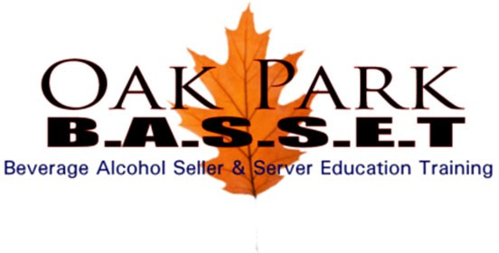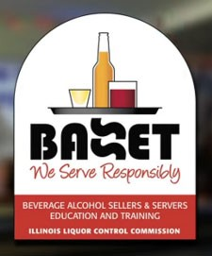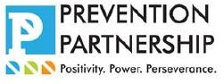
Illinois Beverage Alcohol Sellers & Servers Education and Training
Trainer(s):  Daryl Edwards | ❑ Eric Edwards | ❑ Beverly Walker Donley

BASSET Agenda

Online Materials at http://www.oakparkbasset.com/covid‐19/

PHONE CONFERENCE (12:00 pm – 1:00 pm) – 1hr

- Welcome & Introduction

- Pre‐Test (DONE BEFORE CLASS)

- BASSET Overview & Discussions

ONLINE STUDY (1:00 pm – 2:30 pm) – 1 ½ hrs or Take a Break if “Done Before Class” 1 of 3
Instructors will remain on conference.

- Video Presentation – ILLCC
- Video Presentation – Drunk Bars

- PowerPoint Presentation Oak Park BASSET 1 & 2 by Daryl Edwards

  - Scope of the Problem ‐ ILLCC AREA 1: PHYSICAL PROPERTIES OF ALCOHOL, DRUGS & ALCOHOLISM
  - Liquor Control Regulations ‐ ILLCC AREA 3: ILLINOIS STATE STATUTES, LOCAL ORDINANCES, ILLINOIS DUI LAWS. ILLCC AREA 5: DRAM SHOP LIABILITIES, INSURANCE, AND VICTIM'S RIGHTS

  - Preventing Underage Sales ‐ ILLCC AREA 4: PROPER IDENTIFICATION TECHNIQUES, POLICE POLICIES & EXPECTATIONS

  - Alcohol Management ‐ ILLCC AREA 1: PHYSICAL PROPERTIES OF ALCOHOL & DRUGS. . ILLCC AREA 2: PREVENTION & INTERVENTION TECHNIQUES

PHONE CONFERENCE (2:30 pm – 4:00 pm) – 1 ½ hrs

- Post Test (Final Exam) Review, Questions & Answers

- Certification Guidelines / Adjourn

